1)Question: <https://leetcode.com/problems/kids-with-the-greatest-number-of-candies/description/>

Solution link: <https://leetcode.com/problems/kids-with-the-greatest-number-of-candies/submissions/1342584511/>

Screenshot

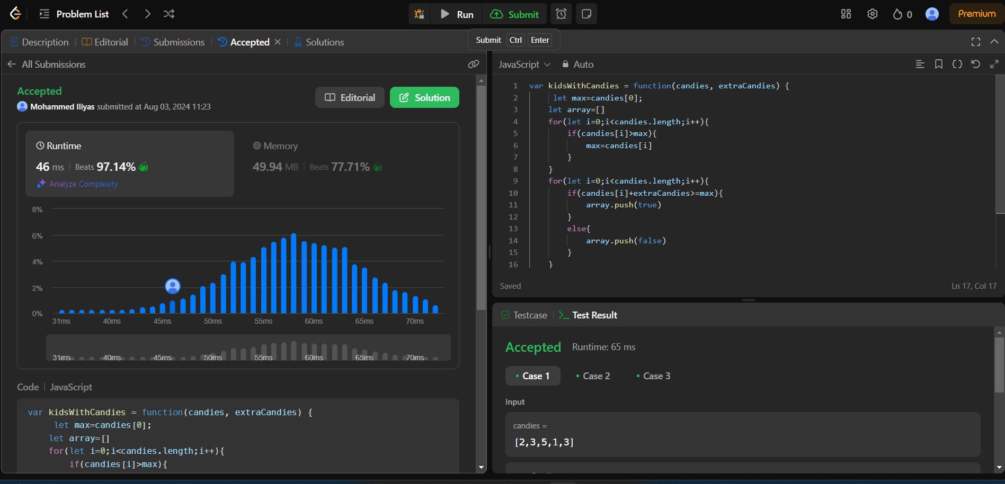

Description: O(n) is a time complexity

O(1) is a space complexity

2)Question: <https://leetcode.com/problems/count-number-of-pairs-with-absolute-difference-k/description/>

Solution: <https://leetcode.com/problems/count-number-of-pairs-with-absolute-difference-k/submissions/>

Screenshot

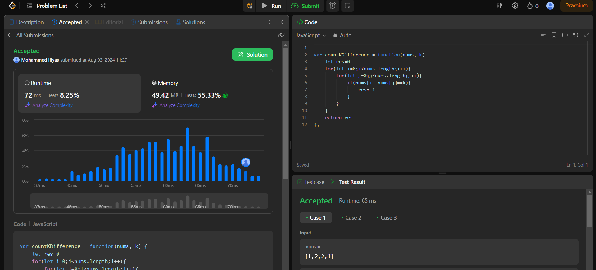

Description: O(n2) is time complexity

O(1) is space complexity

3)Question: <https://leetcode.com/problems/find-common-elements-between-two-arrays/description/>

Solution: <https://leetcode.com/problems/find-common-elements-between-two-arrays/post-solution/?submissionId=1342574857>

Screenshot:

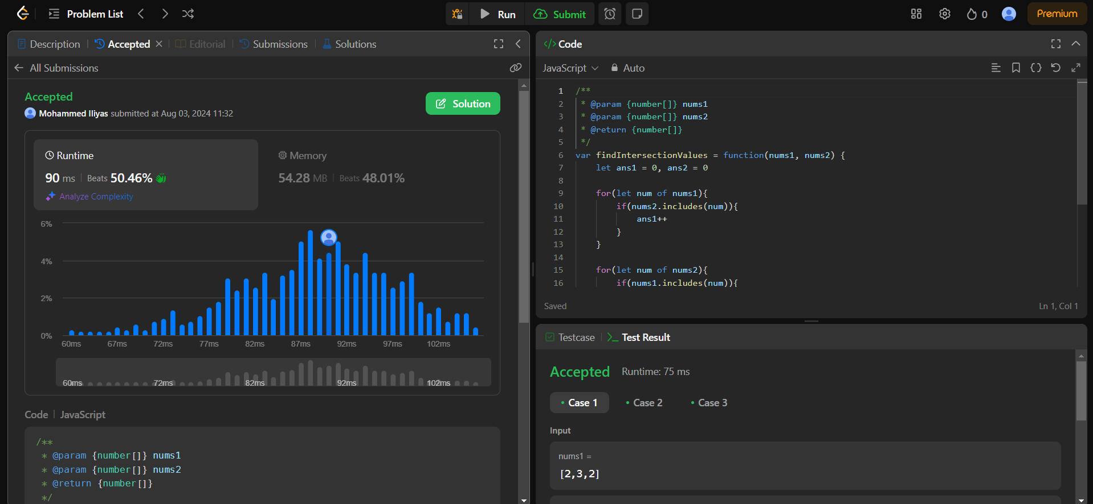

Description: Time Complexity is O(n)

Space Complexity is O(n)

4)Question: <https://leetcode.com/problems/number-of-good-pairs/description/>

Solution: <https://leetcode.com/problems/number-of-good-pairs/post-solution/?submissionId=1335966438>

Screenshot:

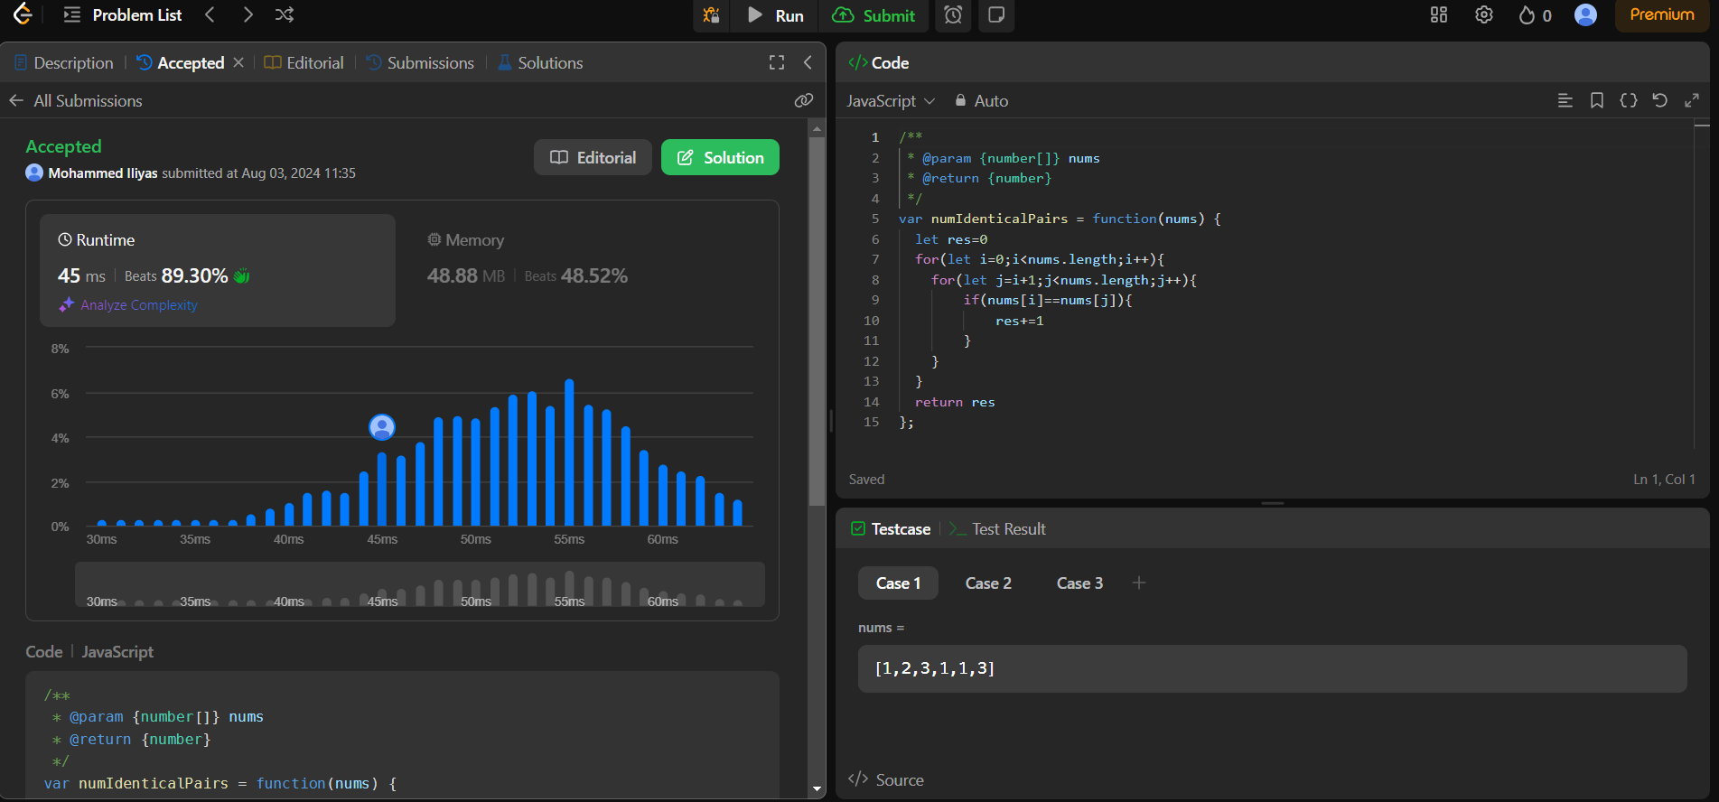

Description : Time Complexity is O(n)

Space Complexity is O(n)